Heart Attack Risk Level Analysis

📌 Project Overview
This project focuses on analyzing and visualizing key health indicators to assess heart attack risk levels. Using a structured medical dataset containing various cardiovascular and biochemical parameters, the goal is to extract insights, explore risk patterns, and support decision-making in heart disease diagnostics.

📁 Dataset Description
The dataset contains patient-level information with the following columns:
- Age: Patient age in years
- Gender: Male or Female
- Heart rate: Heart rate in beats per minute
- Systolic blood pressure: Pressure during heartbeats (mmHg)
- Diastolic blood pressure: Pressure between heartbeats (mmHg)
- Blood sugar: Blood glucose levels (mg/dL)
- CK-MB: Creatine kinase-MB levels (enzyme marker for myocardial infarction)
- Troponin: Cardiac troponin levels (key indicator of heart injury)
- Result: Diagnostic result (e.g., Positive/Negative for heart attack)
- Risk_Level: Categorical risk assessment (Low, Medium, High)
- Recommendation: Suggested medical follow-up (text-based)

🎯 Objectives
- Explore patient demographic and clinical characteristics
- Understand the relationship between biomarkers and heart attack risk
- Visualize how gender, age, and medical indicators influence risk levels
- Use statistical and visual techniques to uncover patterns

📊 Exploratory Data Analysis & Visualization

1. Age Distribution (Countplot)
Goal: Visualize the distribution of patients by age group.
sns.countplot(data=df, x='Age', palette='coolwarm')
plt.title('Age Distribution of Patients')
plt.xlabel('Age')
plt.ylabel('Count')
plt.xticks(rotation=45)
plt.show()
📝 Insight: Helps identify which age groups are most represented in the data, potentially aligning with at-risk populations.

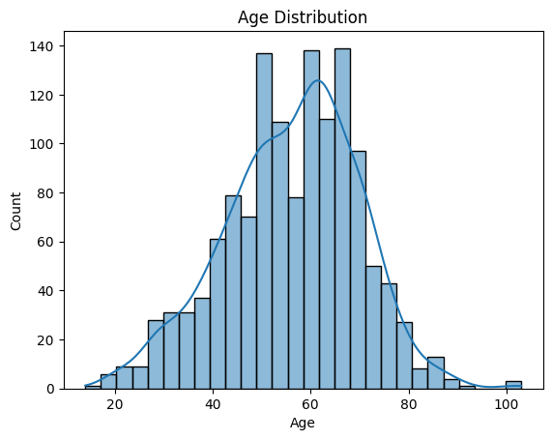

2. Age vs. Risk Level (Boxplot)
Goal: Compare age distributions across different heart attack risk levels.
sns.boxplot(data=df, x='Risk_Level', y='Age', palette='Set2')
plt.title('Age Distribution by Risk Level')
plt.xlabel('Risk Level')
plt.ylabel('Age')
plt.show()
📝 Insight: Reveals whether higher-risk patients tend to be older or younger, supporting risk stratification strategies.
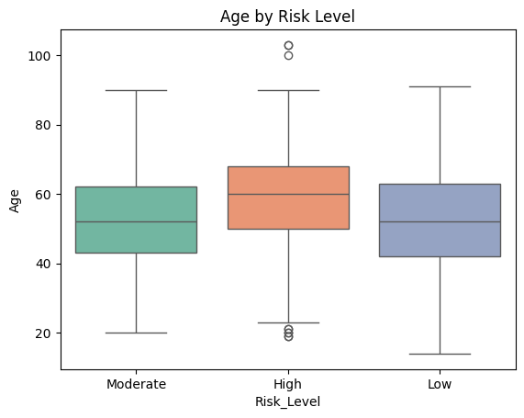

3. Risk Level Count by Gender (Countplot)
Goal: Explore the distribution of risk levels across genders.
sns.countplot(data=df, x='Gender', hue='Risk_Level', palette='pastel')
plt.title('Risk Level Distribution by Gender')
plt.xlabel('Gender')
plt.ylabel('Count')
plt.show()
📝 Insight: Investigates potential gender differences in risk exposure and may indicate gender-specific preventive care needs.

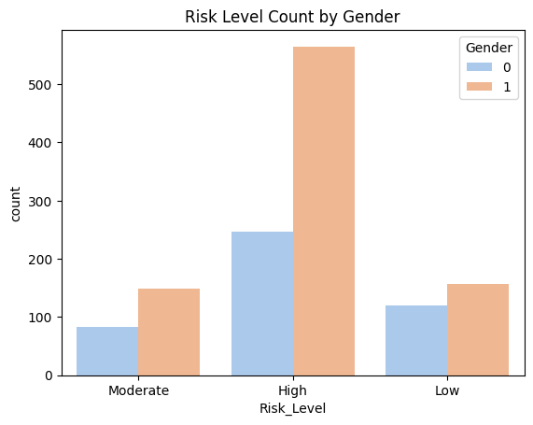

4. Joint Distribution of Blood Pressure (Systolic vs Diastolic)
Goal: Analyze the joint distribution of systolic and diastolic blood pressure, colored by heart attack result.
sns.jointplot(
data=df,
x='Systolic blood pressure',
y='Diastolic blood pressure',
hue='Result',
kind='scatter',
palette='cool'
)
📝 Insight: Helps identify clusters or outliers in blood pressure readings associated with positive heart attack results.
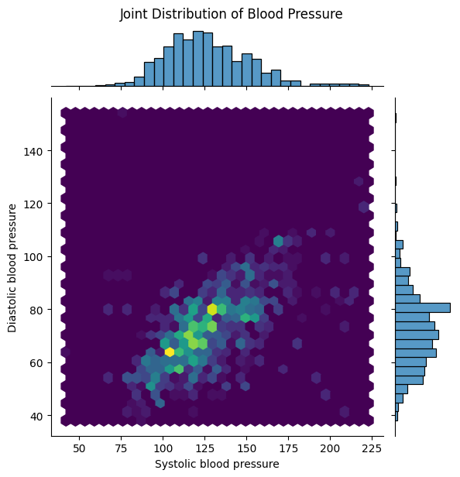

5. Troponin vs. CK-MB (Jointplot Colored by Result)
Goal: Study how two key biomarkers for heart injury relate to diagnostic outcomes.
sns.jointplot(
data=df,
x='CK-MB',
y='Troponin',
hue='Result',
kind='kde', # or 'scatter' for raw plot
palette='Reds')
plt.show()

📝 Insight: Highlights whether higher concentrations of cardiac enzymes correlate with positive diagnosis, which supports clinical interpretations.

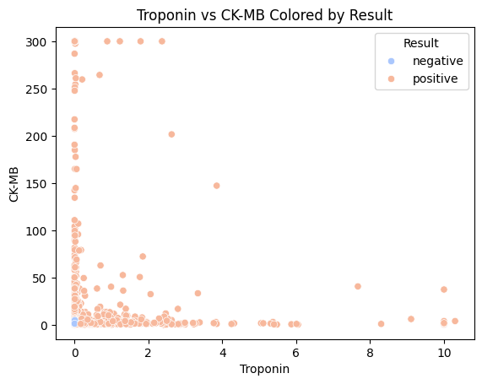

6. Correlation Heatmap
Goal: Explore pairwise correlations between numerical features.
plt.figure(figsize=(10, 6))
sns.heatmap(
df.corr(numeric_only=True),
annot=True,
cmap='coolwarm',
fmt=".2f")
plt.title('Correlation Heatmap')
plt.show()
📝 Insight: Identifies which features are strongly interrelated, helping in feature selection for modeling or deeper analysis.
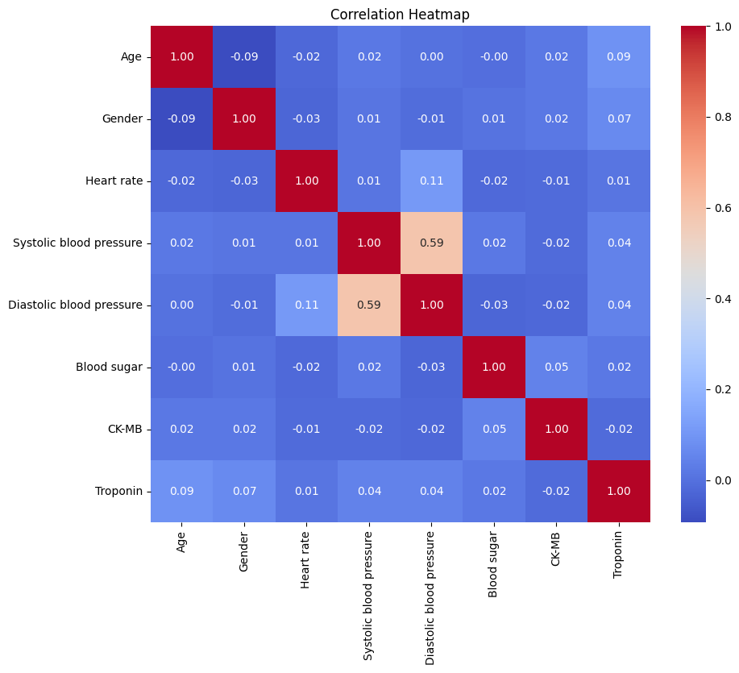

✅ Key Takeaways
- Age and cardiac biomarkers like Troponin and CK-MB show strong associations with risk levels.
- Gender disparities in risk levels were observed, which may indicate biological or lifestyle factors.
- Blood pressure interactions offer additional risk signal, particularly when combined with enzyme data.
- Correlation matrix confirms the importance of several clinical metrics in predicting heart attack risk.
🧰 Technologies Used
- Python 3.x
- Pandas for data manipulation
- Seaborn / Matplotlib for visualizations
- Jupyter Notebook for interactive exploration

